LAB Logbook – Machine Learning

SID - 2360920

Lab 1

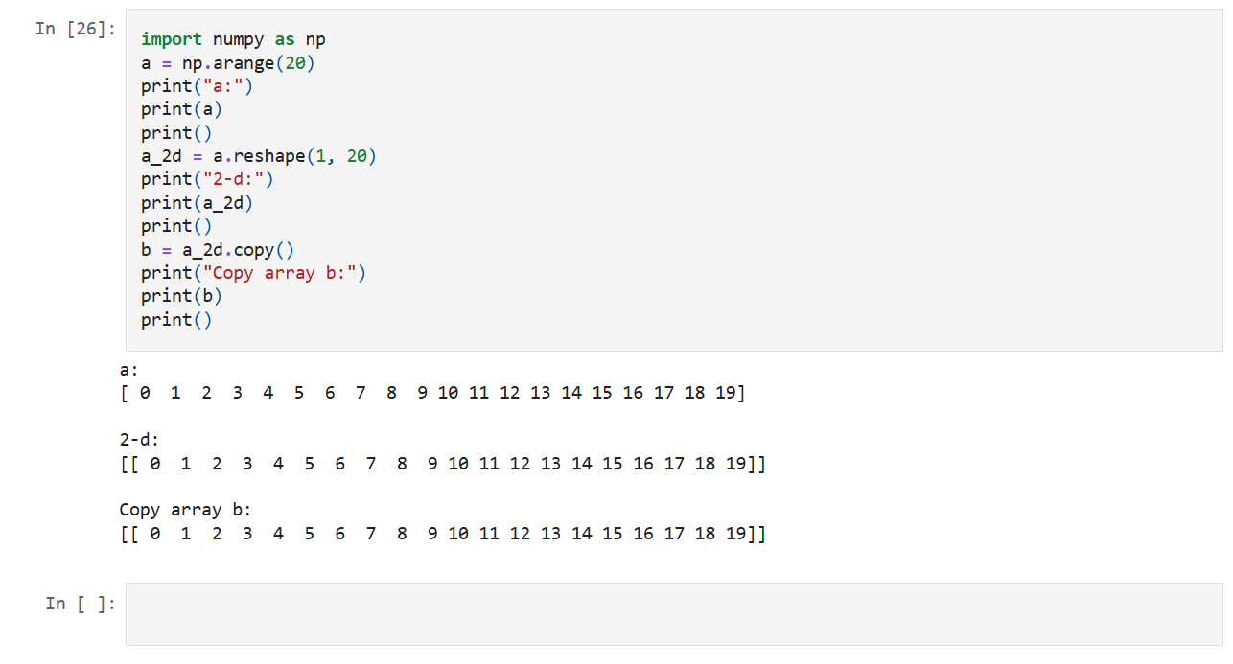

Lab 2

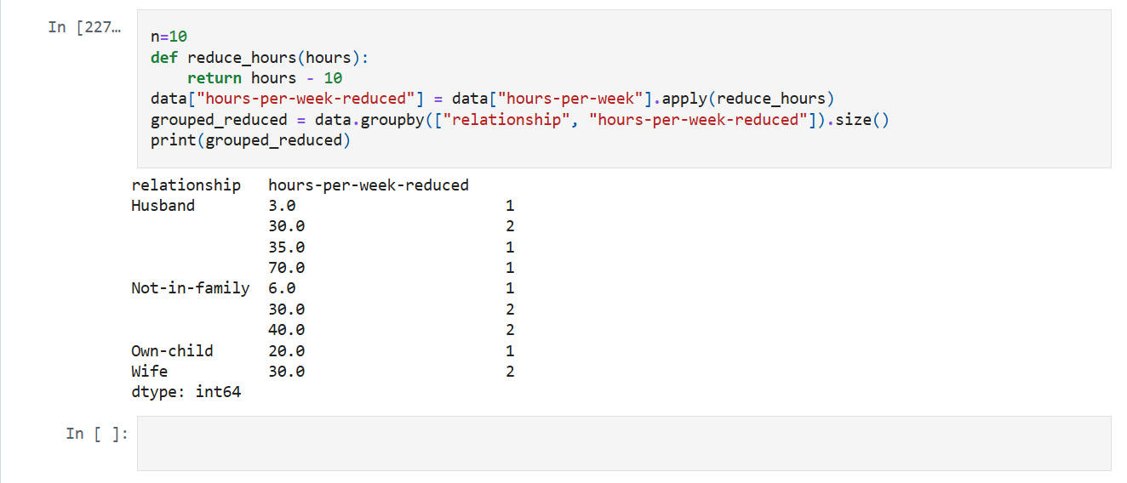

Lab 3

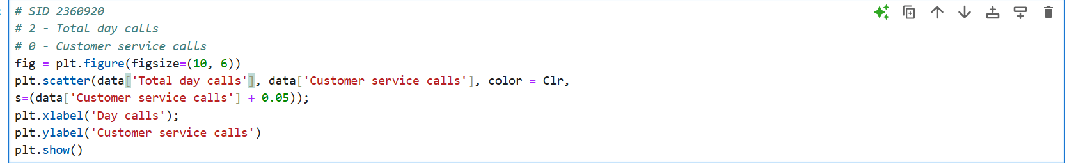

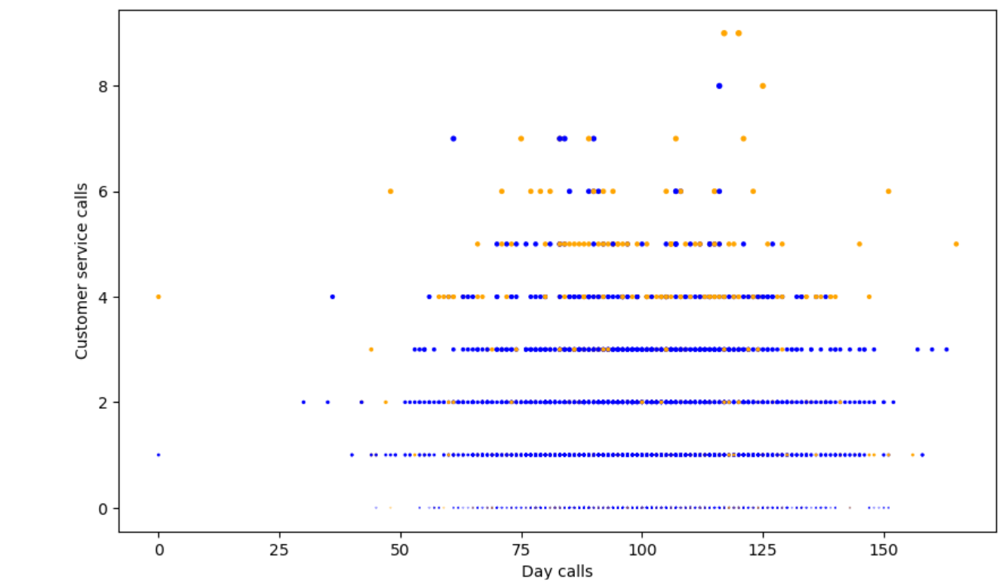

Lab 4

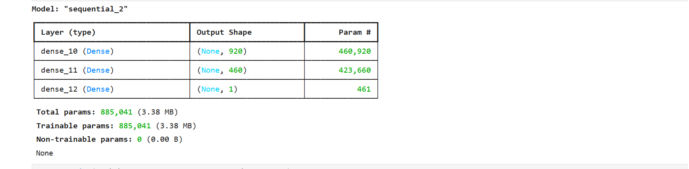

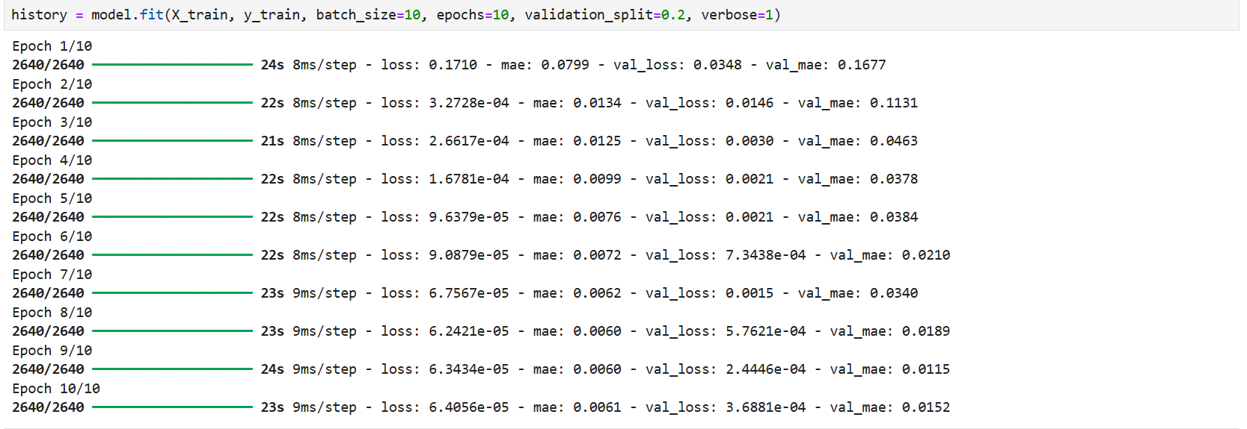

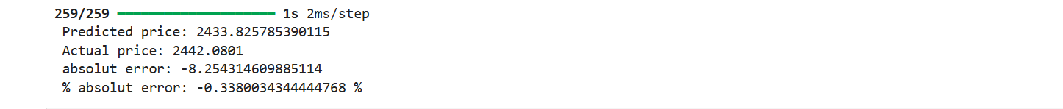

Lab 5

Lab 6

Lab 7

Lab 8

Lab 9

Lab 10

Lab 11

Lab 12